KISARAWE DISTRIC COUNCIL
TFS LOGO
Kisarawe District is one among nine Districts in Coast Region, it is 15 km on the outskirts of Dar es Salaam city towards the east north It’s headquarter is about 15 minutes drive from Julius International Airport.
The district is endowed abundant and unique natural resources, together with miombo type and savannah natural vegetation in some parts especially in Chole and Mzenga Divisions. The natural forest reserves of Kazimzumbwi, Pugu and part of Mwalimu Nyerere National Park in Vikumburu Ward are of special importance.
Kisarawe is home to many ethnic group, including, Wazaramo. Different cultures including people of Arab descent coexist in Kisarawe making the town a peaceful and friendly place for visitors from all over the world.

KISARAWE TUORIST ATTRACTIONS

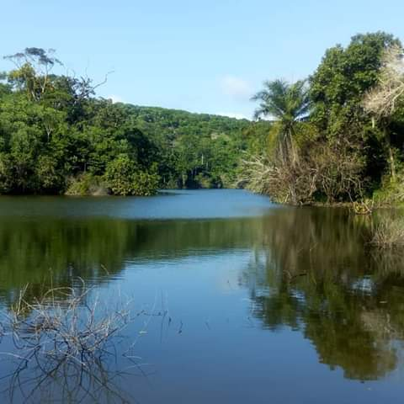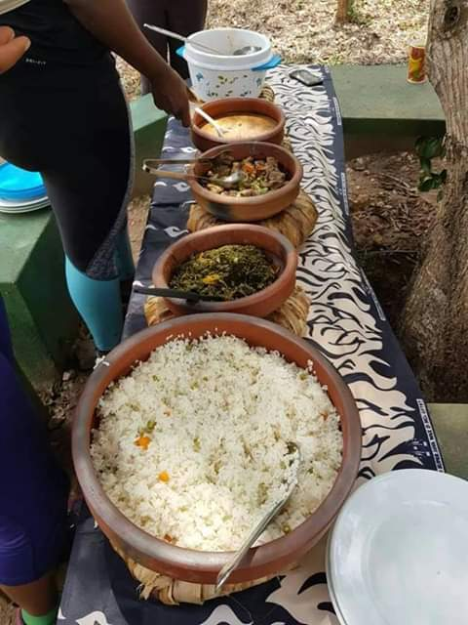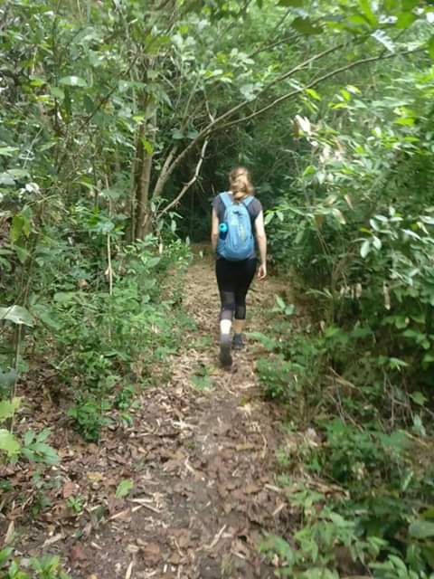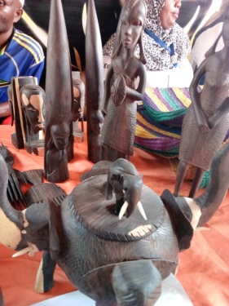

KISARAWE TUORIST ATTRACTIONS

Here are some places to visit.
- Pugu nature reserve tour
- Mwambisi colline bats caves tour
- Biking from Pugu to kisarawe, Mapopo Caves to cattle market at Pugu
- Kisrawe town Mrembo tour
- Learn how to prepare Swahili Traditional food tour
- Maneromango Lutheran Church tour
- Visit Boga artisans groups (day or multiple days) tours
- Chang’ombe “A” and Sembe at north Maneromango village falling meteorites tour
- Local home visits tour
- Visit Kisangile German Headquarter (German Fort) caves and ruins
- British army Grave (PANGA LA MWINGEREZA tour
- Ruvu River tour
KISARAWE TOWN TOURS
Pugu nature reserve tour
Visit Pugu & kazimzumbwi forest which located 15km from Mwalimu Julius Kambarage Nyerere International Airport, it is contains different species of birds, trees species, bat caves, ritual areas, nature trails for hiking Pugu hills, kinyanyiko & bamboo campsites, view tower, area for flying camp, picnic, butterflies watching, rubber trees, valleys and birds watching
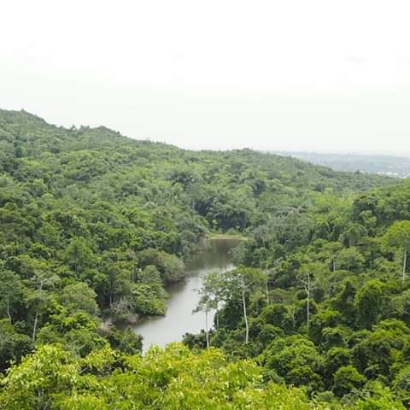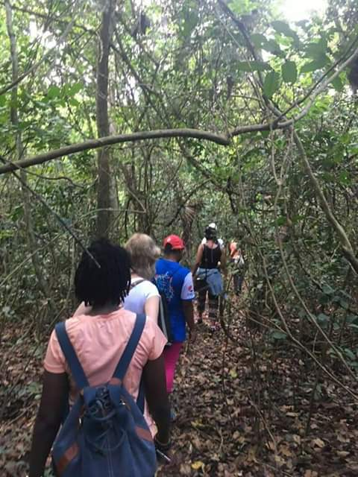
Nature trail & minaki dam in Pugu Forest

Mwambisi colline bats caves Tour
Take an evening or Morning tour to Mapopo caves Mwambisi where thousands of bats have inhabited the caves. Get to know the bat’s life with Cockroach and ecological importance of this living organism.
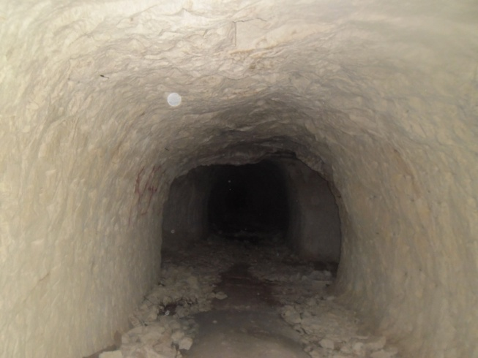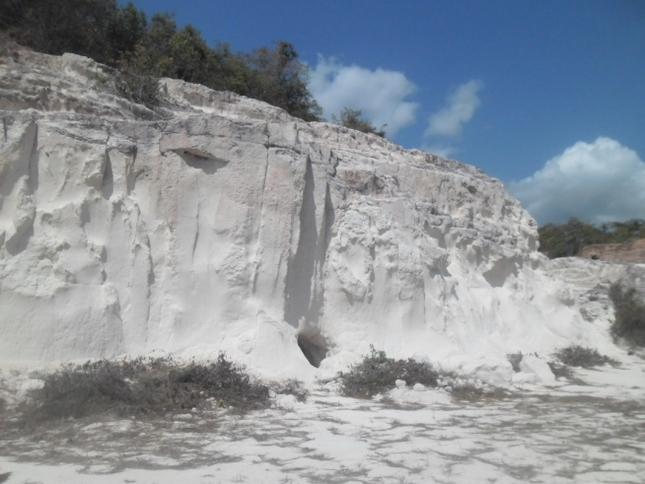
Mwambisi colline deposit & bats caves

Biking from Pugu to kisarawe, Mapopo Caves to cattle market at Pugu
Bike from Pugu to kisarawe town and get an amazing opportunity to view birds, butterflies, flowers, tree, valleys, pugu hills and good visual of Dar es Salaam city

Sanze Village
Here you will visit, Chief Sanze grave, first German leader grave (Missionary) Slaveries grave burred together and first District Commissioner office
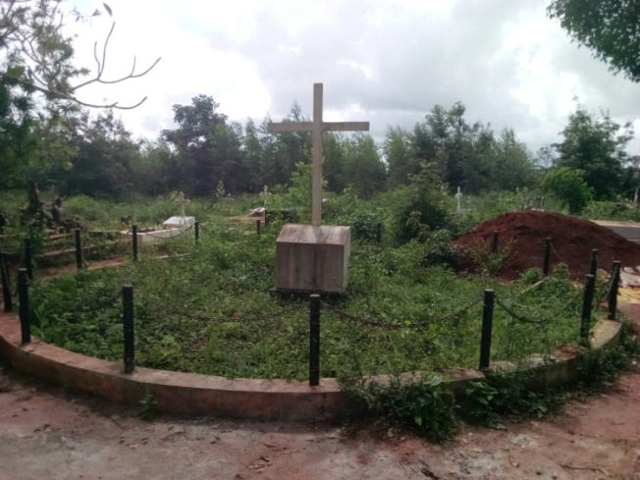
Slaveries grave burred together

Kisarawe town Mrembo tour
Here we will visit the local mama and visitors will get Swahili beauty treatment which included hair plating, Swahili body scrub made from the local recipe, Henna painting and coconut oil making from the scratch and the visitors will take the oil with them afterward. While being treated the host family will also prepare the lunch an after the treatment then visitors will have their lunch.
Learn how to prepare Swahili Traditional food tour
Participate in cooking Swahili dishes with local Swahili Mamas of Kisarawe town and climbing coconut trees.
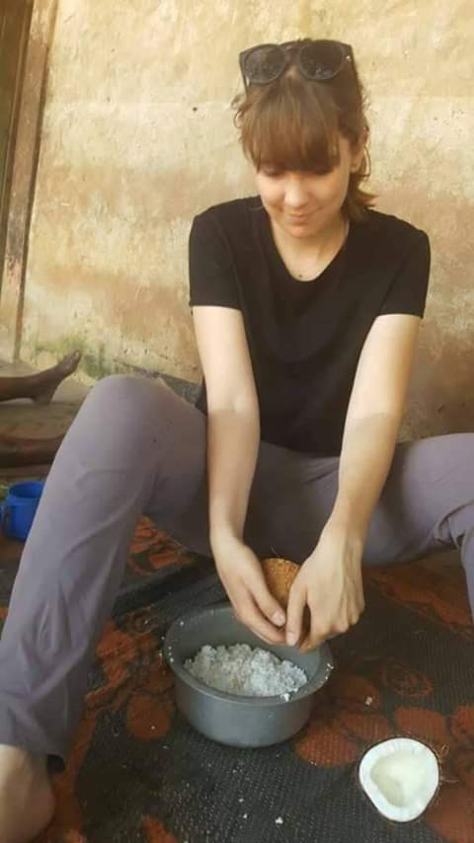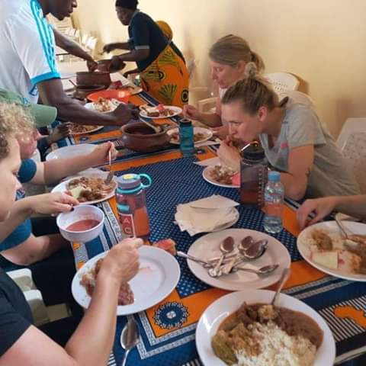
Preparation & eating Swahili food

N.B all tours are half day tour.

MANEROMANGO & BOGA VILLAGES TOUR (LOCATED 55KM FROM KISARAWE TOWN)

Maneromango Lutheran Church tour
Visit the Old tower of the first Lutheran Church in Kisarawe, one of the oldest bible colleges, German grave, explore the museum with information about the missionaries in coastal area, life of the people and some collections of artifacts of the indigenous tribes.
Visit Boga artisans groups (day or multiple days) tours
Participate in cooking Swahili dishes with local Swahili Mamas of Boga villages and climbing coconut trees, Kungwi and Ngariba informal teaching, traditional dances, Mwali teaching made by Kungwi, traditional painting, traditional carving, cultural dancing and drumming.
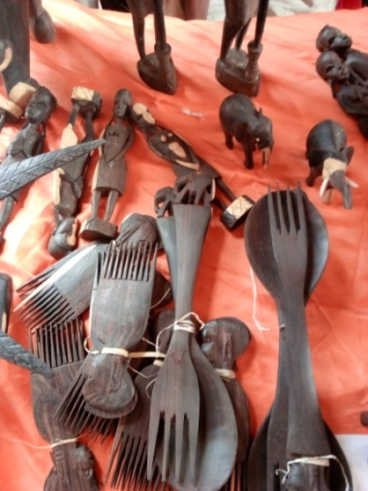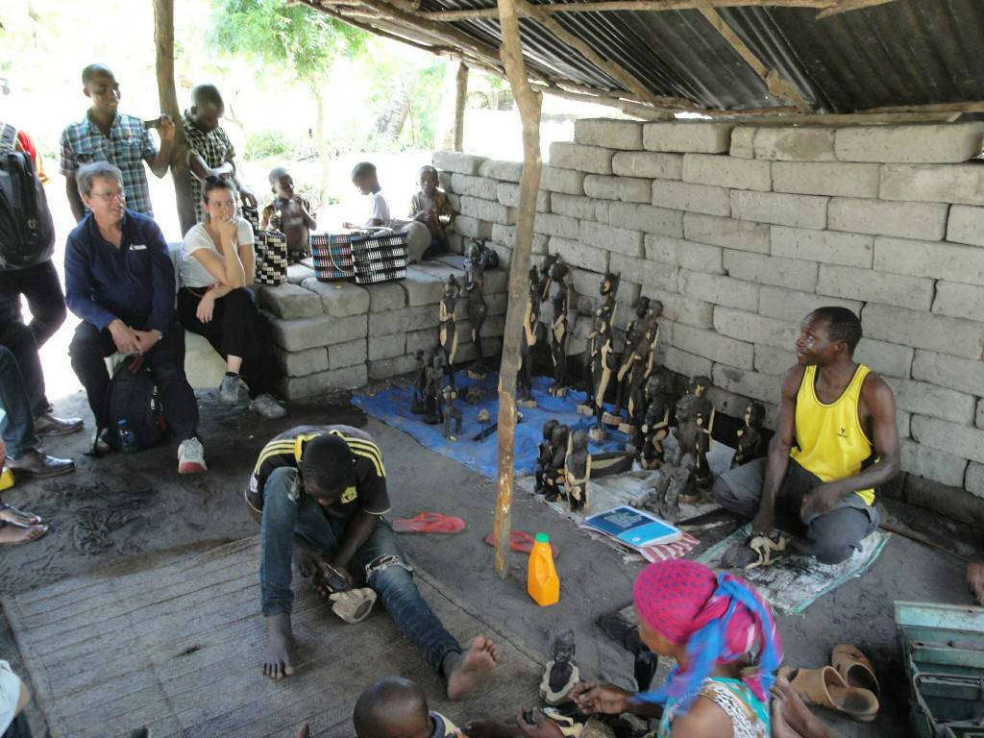
Boga & Msimbu Artisan

Chang’ombe “A” and Sembe at north Maneromango village falling meteorites tour
In this place you will see a meteorite like substances which are believed to fall on the place many years back. These rocks “meteorites like substances” are on the process of research to confirm that are meteorites.
“The attracting thing here is existence of these huge masses of rock on the flat free rock crust. The scenery of the place is seen to be invaded with these rocks from the sky”

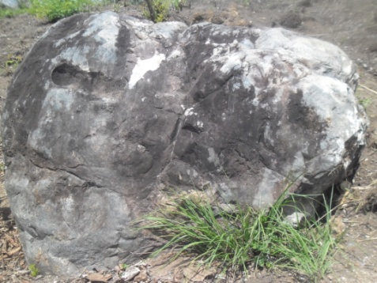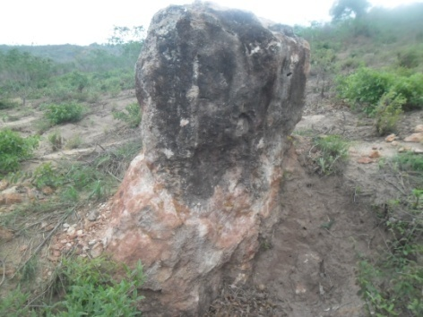
Chang’ombe “A” and Sembe at north Maneromango village falling meteorites

Local Home visits tour
Visit to a local home where you will learn how coastal communities lives. Listen to stories and share your time with local people by engaging in various home chores/daily activities. Learn how to prepare cassava as breakfast

CHOLE & VIKUMBURU VILLAGES TOURS (80KM FROM KISARAWE TOWN)
Visit Kisangile German Headquarter (German Fort) caves and ruins
This was the first Headquarter of German in Kisarawe. German leader built headquarter for army before world war I 1914, place German army fight with British army, the place built underground two way which was for escaping German leader during war either local communities or other nation

British army Grave (PANGA LA MWINGEREZA) tour
Visit British army Grave PANGA LA MWINGEREZA at Chole division which in this village where German leader preferred to settles and construct administrative and military headquarters. Beyond the ruins, there is an old building surrounded by a natural forest where one can go closer to nature and enjoy fresh air, bird and butterflies and natural forest, also you will visit god bridge in Mtunani Chole which historical established by villagers during German era.
Ruvu River tour
Take a car ride to explore crocodiles, and various birds’ huts along the Ruvu River that flows from the Uluguru Mountains and some parts of Southern Highlands of Tanzania. Get to know how local’s fishing in the rivers and various used of river water.
NB all tours are Half day trip
Road: - The road from Dar es Salaam business city to Mwalimu Nyerere National Park which passes through Kisarawe district is about 167 kilometers from Mwalimu Julius Kambarage Nyerere International Airport (JKNIA), it is shorter than the road compare from Dar es Salaam through Kibiti which is more than 240 kilometers and this makes a different of 73 kilometers. Equally important Kisarawe district is very nearby Mwalimu Julius Kambarage Nyerere Dar es Salaam international airport.

Tourist accommodation Investment area In Kisarawe District we do have surveyor areas bordering Mwalimu Nyerere National Park, Pugu and Kazimzumbwi which are suitable for establishment of Eco-lodge, Hotel and campsite we would like to inform investors for investment.

Getting there
Kisarawe District, it is 25 kms on the outskirts of Dar es Salaam city Centre towards the east north, It’s headquarter is about 15km from Mwalim Julius Kambarage Nyerere International Airport minutes drive from Julius International Airport. One can catch daily buses commuting between Dar-Es-Salaam-Gongo la mboto local bus stations to Kisarawe town.

